Name: Anjali Arvind Shirke Roll No : 07
Assignment 13

Aim

MNIST Handwritten Character Detection using PyTorch, Keras, and TensorFlow.

In [6]:
import torch
from torch import nn, optim
from torchvision import datasets, transforms
from torch.utils.data import DataLoader
import matplotlib.pyplot as plt

In [7]:
transform = transforms.Compose([ transforms.ToTensor(),
transforms.Normalize((0.5,), (0.5,))
])

trainset = datasets.MNIST(root='mnist_data', train=True, download=True, transfor trainloader = DataLoader(trainset, batch_size=64, shuffle=True)

testset = datasets.MNIST(root='mnist_data', train=False, download=True, transfor testloader = DataLoader(testset, batch_size=100, shuffle=False)

print(f'Training samples: {len(trainset)}') print(f'Test samples: {len(testset)}')

Training samples: 60000
Test samples: 10000

In [8]:
class SimpleCNN(nn.Module):
def init (self):
super(SimpleCNN, self). init ()
self.conv1 = nn.Conv2d(1, 32, 3, 1)
self.conv2 = nn.Conv2d(32, 64, 3, 1) self.fc1 = nn.Linear(1600, 128)
self.fc2 = nn.Linear(128, 10)

def forward(self, x):
x = nn.functional.relu(self.conv1(x)) x = nn.functional.max_pool2d(x, 2)
x = nn.functional.relu(self.conv2(x)) x = nn.functional.max_pool2d(x, 2)
x = torch.flatten(x, 1)
x = nn.functional.relu(self.fc1(x)) x = self.fc2(x)
return nn.functional.log_softmax(x, dim=1)

pt_model = SimpleCNN() print(pt_model)

SimpleCNN(
(conv1): Conv2d(1, 32, kernel_size=(3, 3), stride=(1, 1))
(conv2): Conv2d(32, 64, kernel_size=(3, 3), stride=(1, 1))
(fc1): Linear(in_features=1600, out_features=128, bias=True) (fc2): Linear(in_features=128, out_features=10, bias=True)
)

In [9]:
criterion = nn.NLLLoss()
optimizer = optim.Adam(pt_model.parameters(), lr=0.001)

pt_epochs = 2
for epoch in range(pt_epochs): pt_model.train()
running_loss = 0.0
correct = 0
total = 0
for images, labels in trainloader: optimizer.zero_grad()
output = pt_model(images)
loss = criterion(output, labels) loss.backward()
optimizer.step()

running_loss += loss.item()
_, predicted = torch.max(output, 1) total += labels.size(0)
correct += (predicted == labels).sum().item()

epoch_loss = running_loss / len(trainloader) epoch_acc = correct / total
print(f'Epoch [{epoch+1}/{pt_epochs}] Loss: {epoch_loss:.4f} Accuracy: {ep

print('\nPyTorch training complete.')

Epoch | [1/2] Loss: 0.1497 Accuracy: | 0.9546
Epoch | [2/2] Loss: 0.0444 Accuracy: | 0.9862

PyTorch training complete.

In [10]:
pt_model.eval() correct = 0
total = 0
with torch.no_grad():
for images, labels in testloader: output = pt_model(images)
_, predicted = torch.max(output, 1) total += labels.size(0)
correct += (predicted == labels).sum().item()

pt_accuracy = correct / total
print(f'PyTorch Test Accuracy: {pt_accuracy:.4f}')

PyTorch Test Accuracy: 0.9860

In [12]:
import numpy as np pt_model.eval()
pt_predictions = []
with torch.no_grad():
for images, _ in testloader: output = pt_model(images)
_, predicted = torch.max(output, 1)

pt_predictions.extend(predicted.cpu().numpy()) pt_predictions = np.array(pt_predictions)

import numpy as np
# Use the PyTorch test set images for plotting
x_test_pt = testset.data.numpy() # shape (10000, 28, 28)
y_test_pt = testset.targets.numpy()

fig, axes = plt.subplots(2, 5, figsize=(12, 5)) np.random.seed(42)
indices = np.random.choice(len(x_test_pt), 10, replace=False)
for i, idx in enumerate(indices): ax = axes[i // 5, i % 5]
ax.imshow(x_test_pt[idx], cmap='gray') pred = pt_predictions[idx]
actual = y_test_pt[idx]
color = 'green' if pred == actual else 'red'
ax.set_title(f'Pred: {pred}\nActual: {actual}', color=color, fontweight='bol ax.axis('off')
plt.suptitle('PyTorch Model: Predictions on Test Images', fontweight='bold', fon plt.tight_layout()
plt.show()
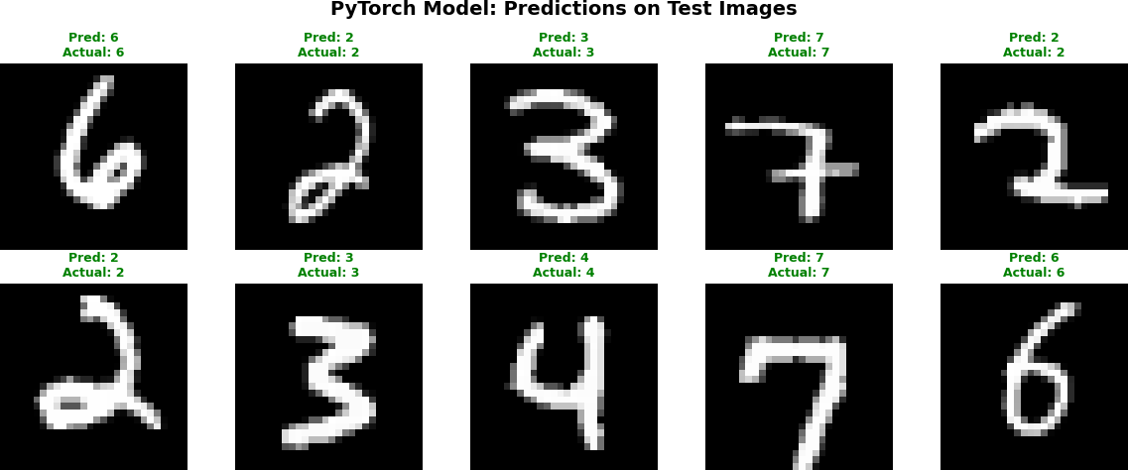

In [13]:
import tensorflow as tf
from tensorflow.keras import layers, models
from tensorflow.keras.datasets import mnist as keras_mnist
import numpy as np

In [14]:
(x_train, y_train), (x_test, y_test) = keras_mnist.load_data()

x_train = x_train.reshape(-1, 28, 28, 1).astype('float32') / 255.0
x_test = x_test.reshape(-1, 28, 28, 1).astype('float32') / 255.0

print(f'Training data shape: {x_train.shape}') print(f'Test data shape: {x_test.shape}')

Downloading data from https://storage.googleapis.com/tensorflow/tf-keras-dataset s/mnist.npz
11490434/11490434 ━━━━━━━━━━━━━━━━━━━━ 3s 0us/step Training data shape: (60000, 28, 28, 1)
Test data shape: (10000, 28, 28, 1)

In [16]:
k_model = models.Sequential([
layers.Conv2D(32, (3, 3), activation='relu', input_shape=(28, 28, 1)),

layers.MaxPooling2D((2, 2)),
layers.Conv2D(64, (3, 3), activation='relu'),
layers.MaxPooling2D((2, 2)), layers.Flatten(),
layers.Dense(64, activation='relu'), layers.Dense(10, activation='softmax')
])

k_model.compile(
optimizer='adam',
loss='sparse_categorical_crossentropy', metrics=['accuracy']
)

k_model.summary()

Model: "sequential_1"
┏━━━━━━━━━━━━━━━━━━━━━━━━━━━━━━━━━━━━━━┳━━━━━━━━━━━━━━━━━━━━━━━━━━━━━┳━━━━

┃ Layer (type) ┃ Output Shape ┃
┡━━━━━━━━━━━━━━━━━━━━━━━━━━━━━━━━━━━━━━╇━━━━━━━━━━━━━━━━━━━━━━━━━━━━━╇━━━━

│ conv2d_2 (Conv2D) │ (None, 26, 26, 32) │
├──────────────────────────────────────┼─────────────────────────────┼────

│ max_pooling2d_2 (MaxPooling2D) │ (None, 13, 13, 32) │
├──────────────────────────────────────┼─────────────────────────────┼────

│ conv2d_3 (Conv2D) │ (None, 11, 11, 64) │
├──────────────────────────────────────┼─────────────────────────────┼────

│ max_pooling2d_3 (MaxPooling2D) │ (None, 5, 5, 64) │
├──────────────────────────────────────┼─────────────────────────────┼────

│ flatten_1 (Flatten) │ (None, 1600) │
├──────────────────────────────────────┼─────────────────────────────┼────

│ dense_2 (Dense) │ (None, 64) │
├──────────────────────────────────────┼─────────────────────────────┼────

│ dense_3 (Dense) │ (None, 10) │
└──────────────────────────────────────┴─────────────────────────────┴────
C C
Total params: 121,930 (476.29 KB)
Trainable params: 121,930 (476.29 KB)
Non-trainable params: 0 (0.00 B)

In [17]:
k_model.fit(x_train, y_train, epochs=2, batch_size=64, validation_split=0.1, ver

Out[17]:

In [18]:
k_loss, k_accuracy = k_model.evaluate(x_test, y_test, verbose=0) print(f'Keras Test Loss: {k_loss:.4f}')
print(f'Keras Test Accuracy: {k_accuracy:.4f}')
Epoch 1/2
844/844 - 20s - 24ms/step - accuracy: 0.9410 - loss: 0.1943 - val_accuracy: 0.983
7 - val_loss: 0.0591 Epoch 2/2
844/844 - 18s - 21ms/step - accuracy: 0.9823 - loss: 0.0561 - val_accuracy: 0.984
5 - val_loss: 0.0494
<keras.src.callbacks.history.History at 0x1b656f3f5f0>

k_predictions = np.argmax(k_model.predict(x_test, verbose=0), axis=1)

Keras Test Loss: 0.0489
Keras Test Accuracy: 0.9838

In [19]:

x_test_plot = x_test.squeeze() y_test_plot = y_test.flatten()

fig, axes = plt.subplots(2, 5, figsize=(12, 5)) np.random.seed(42)
indices = np.random.choice(len(x_test_plot), 10, replace=False)
for i, idx in enumerate(indices): ax = axes[i // 5, i % 5]
ax.imshow(x_test_plot[idx], cmap='gray') pred = k_predictions[idx]
actual = y_test_plot[idx]
color = 'green' if pred == actual else 'red'
ax.set_title(f'Pred: {pred}\nActual: {actual}', color=color, fontweight='bol ax.axis('off')
plt.suptitle('Keras Model: Predictions on Test Images', fontweight='bold', fonts plt.tight_layout()
plt.show()
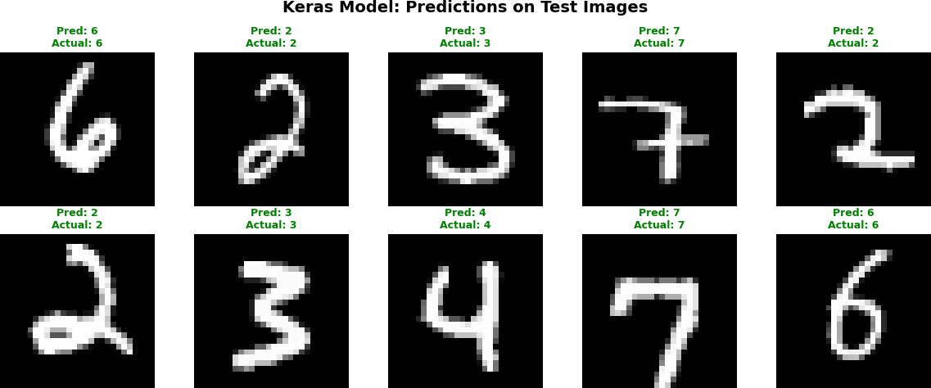

In [20]:
# Build the same architecture but train with GradientTape
tf_model = models.Sequential([
layers.Conv2D(32, (3, 3), activation='relu', input_shape=(28, 28, 1)),
layers.MaxPooling2D((2, 2)),
layers.Conv2D(64, (3, 3), activation='relu'),
layers.MaxPooling2D((2, 2)), layers.Flatten(),
layers.Dense(64, activation='relu'), layers.Dense(10, activation='softmax')
])

tf_optimizer = tf.keras.optimizers.Adam(learning_rate=0.001) tf_loss_fn = tf.keras.losses.SparseCategoricalCrossentropy()

print('TensorFlow low-level model created.')

TensorFlow low-level model created.

In [21]:
# Create TensorFlow dataset
train_ds = tf.data.Dataset.from_tensor_slices((x_train, y_train)).shuffle(10000)

tf_epochs = 2
for epoch in range(tf_epochs): epoch_loss = 0.0
epoch_correct = 0
epoch_total = 0
num_batches = 0

for batch_x, batch_y in train_ds:
with tf.GradientTape() as tape:
predictions = tf_model(batch_x, training=True) loss = tf_loss_fn(batch_y, predictions)

# Compute and apply gradients
gradients = tape.gradient(loss, tf_model.trainable_variables)
tf_optimizer.apply_gradients(zip(gradients, tf_model.trainable_variables

epoch_loss += loss.numpy()
predicted_labels = tf.argmax(predictions, axis=1)
epoch_correct += tf.reduce_sum(tf.cast(predicted_labels == tf.cast(batch epoch_total += len(batch_y)
num_batches += 1

avg_loss = epoch_loss / num_batches
accuracy = epoch_correct / epoch_total
print(f'Epoch [{epoch+1}/{tf_epochs}] Loss: {avg_loss:.4f} Accuracy: {accu

print('\nTensorFlow (GradientTape) training complete.')
Epoch [1/2] Loss: 0.1726 Accuracy: 0.9483
Epoch [2/2] Loss: 0.0521 Accuracy: 0.9843 TensorFlow (GradientTape) training complete.
In [22]:
test_ds = tf.data.Dataset.from_tensor_slices((x_test, y_test)).batch(100)

tf_correct = 0
tf_total = 0
for batch_x, batch_y in test_ds:
predictions = tf_model(batch_x, training=False) predicted_labels = tf.argmax(predictions, axis=1)
tf_correct += tf.reduce_sum(tf.cast(predicted_labels == tf.cast(batch_y, tf. tf_total += len(batch_y)

tf_accuracy = tf_correct / tf_total
print(f'TensorFlow (GradientTape) Test Accuracy: {tf_accuracy:.4f}')

TensorFlow (GradientTape) Test Accuracy: 0.9862

In [23]:
tf_predictions = np.argmax(tf_model(x_test, training=False), axis=1)

fig, axes = plt.subplots(2, 5, figsize=(12, 5)) np.random.seed(42)
indices = np.random.choice(len(x_test), 10, replace=False)
for i, idx in enumerate(indices): ax = axes[i // 5, i % 5]
ax.imshow(x_test[idx].squeeze(), cmap='gray') pred = tf_predictions[idx]
actual = y_test[idx]
color = 'green' if pred == actual else 'red'
ax.set_title(f'Pred: {pred}\nActual: {actual}', color=color, fontweight='bol ax.axis('off')
plt.suptitle('TensorFlow Model: Predictions on Test Images', fontweight='bold', plt.tight_layout()
plt.show()

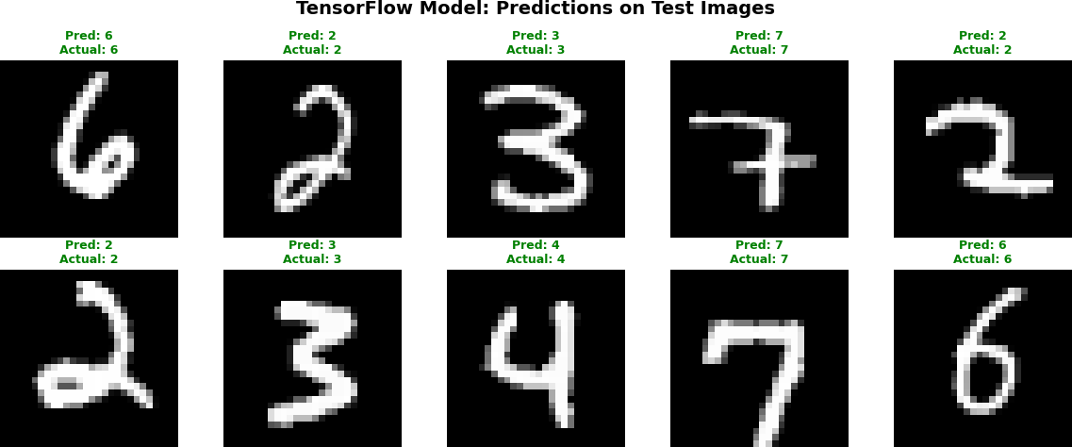

In [24]:
print('=' * 50)
print('Framework Comparison on MNIST') print('=' * 50)
print(f'PyTorch Test Accuracy: {pt_accuracy:.4f}')
print(f'Keras Test Accuracy: {k_accuracy:.4f}') print(f'TensorFlow (manual) Test Accuracy: {tf_accuracy:.4f}') print('=' * 50)

==================================================
Framework Comparison on MNIST
==================================================
PyTorch Test Accuracy: 0.9860
Keras Test Accuracy: 0.9838 TensorFlow (manual) Test Accuracy: 0.9862
==================================================

In [ ]:

